1. In the dataset linked below, some physical and performance data from a random sample of 222 weightlifters have been collected. The variables recorded for each subject are listed below.
Variable Description
id Subject ID
gender Either "Male" or "Female"
bodyweight The weight of the subject
age Age of subject in years
weightlifted The maximum weight lifted by the subject in a specific exercise [not specified]
The data set (whose first 5 records are shown below) can be found on iLearn under Resources in the file:
data.assign2.30.44468423.222.csv
ID gender bodyweight age weightlifted
subj1 Female 86.9 24.3 110.7
subj2 Male 113.0 32.2 180.3
subj3 Female 91.6 33.9 113.4
subj4 Male 104.9 29.5 169.9
subj5 Female 84.1 29.3 116.3
(a) Is there any difference in the average age of male and female weightlifters?
Introduction:
To determine whether there is any difference in the average age of male and female weightlifters from the physical and performance data collected from a random sample of 222 weightlifters.
Methods:
A histogram of age is first drawn by gender separately for female and male. Both the histograms indicate that the normality assumption seems to have been met as the sample shows a normal distribution.
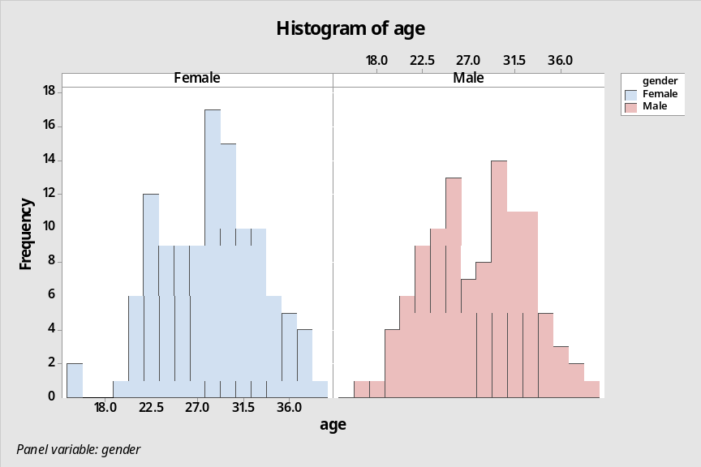
A boxplot of age is then drawn by gender to check the variability and it shows equal spread for both female and male.
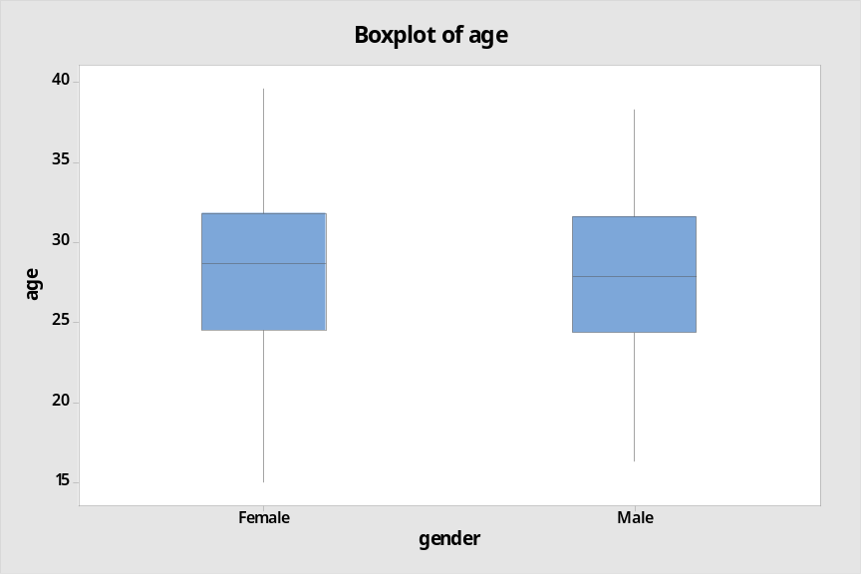
Since we have two independent samples with females and males, a Two-Sample T-Test is performed to verify whether the distribution of age has the same mean for females and males assuming that the samples show normal distribution with equal variances.
The null hypothesis would be that there is no difference between the means of the two samples whereas the alternative hypothesis would be the opposite that there is a difference between the two samples.
Result:
Two-Sample T-Test and CI: age, gender
Method
μ₁: mean of age when gender = Female
µ₂: mean of age when gender = Male
Difference: μ₁ - µ₂
Equal variances are assumed for this analysis.
Descriptive Statistics: age
Gender | N | Mean | StDev | SE Mean
Female | 116 | 28.34 | 4.89 | 0.45
Male | 106 | 27.88 | 4.87 | 0.47

Estimation for Difference
Difference | Pooled  StDev | 95% CI for  Difference
0.462 | 4.882 | (-0.831, 1.755)
Test
Null hypothesis | H₀: μ₁ - µ₂ = 0
Alternative hypothesis | H₁: μ₁ - µ₂ ≠ 0

T-Value | DF | P-Value
0.70 | 220 | 0.482

The test statistic is z = 0.70 and the P-Value is 0.482. Since P-Value is greater than 0.05, the null hypothesis holds true may not be rejected.
Conclusion:
There is insufficient evidence to suggest that the means for females and males are not same. With 95% confidence, we can state that the distribution of age has the same means for females and males.
b) What is the relation between the body weight of weightlifters and the maximum weight they can lift?
Introduction:
To determine whether there is any relationship between the body weight of weightlifters and the maximum weight they can lift.
Methods:
In order to study the relationship between the body weight of weightlifters and the maximum weight they can lift, the data set is split by gender into female and male as they are two independent samples.
When considering the relation between two numerical variables such as weightlifted and bodyweight, we should always look at a scatter plot before any further analysis.
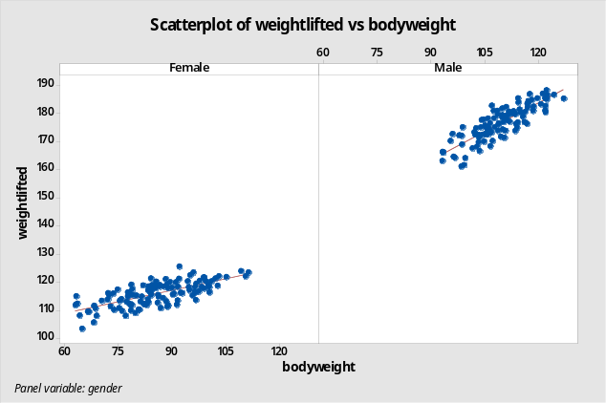
The scatterplots for both females and males shows the residuals grouped closely around the best fitted line suggesting a linear relationship between weightlifted and bodyweight.
This linear relationship satisfies the first condition for linear regression but to perform the regression analysis, the residuals should show a normal distribution and have a constant standard deviation for which Histogram of Residuals and Residuals versus Fits are plotted separately for females and males.
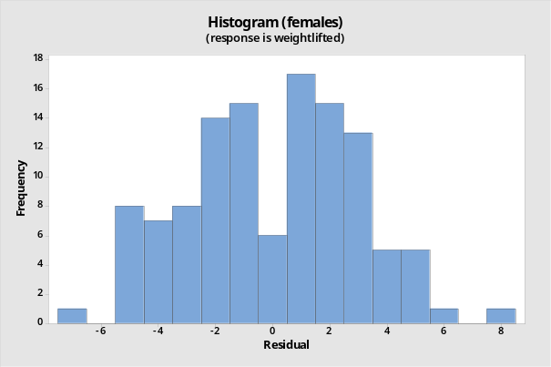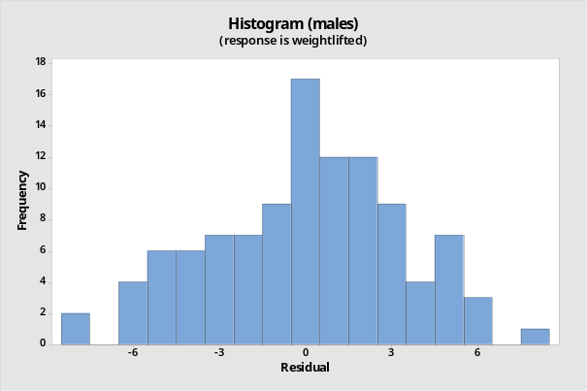
The histogram of the residuals for both females and males show a normal distribution satisfying the second condition for linear regression.
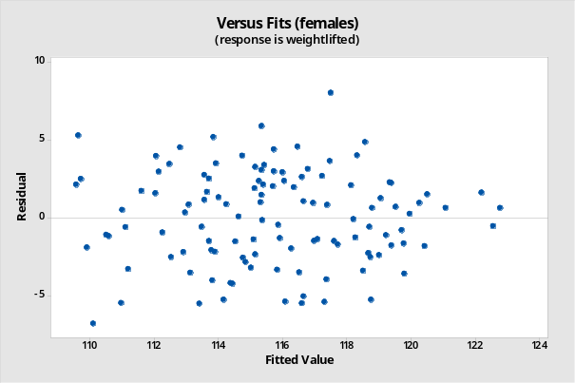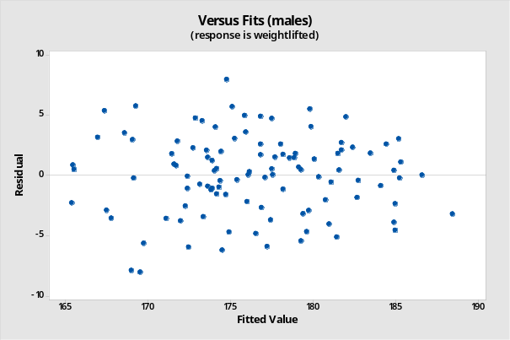
The plot of the residuals versus the fitted values for both females and males show an even scatter of points around zero across the range of the fitted values, indicating that the residuals seem to have a constant standard deviation which satisfies the third and final condition for linear regression.
Result:
Upon satisfying the above three conditions, regression analysis is performed separately for both females and males with the variable weightlifted as Responses and bodyweight as Continuous Predictors.

(Continued in next page)
Regression Analysis: weightlifted versus bodyweight (females)
Analysis of Variance (females)
Source | DF | Adj SS | Adj MS | F-Value | P-Value
Regression | 1 | 1022.56 | 1022.56 | 114.32 | 0.000
bodyweight | 1 | 1022.56 | 1022.56 | 114.32 | 0.000
Error | 114 | 1019.73 | 8.95
Lack-of-Fit | 105 | 924.46 | 8.80 | 0.83 | 0.699
Pure Error | 9 | 95.27 | 10.59
Total | 115 | 2042.29
Model Summary (females)
S | R-sq | R-sq(adj) | R-sq(pred)
2.99082 | 50.07% | 49.63% | 48.42%
Coefficients (females)
Term | Coef | SE Coef | T-Value | P-Value | VIF
Constant | 92.34 | 2.20 | 41.92 | 0.000
Bodyweight | 0.2732 | 0.0255 | 10.69 | 0.000 | 1.00
Regression Equation (females)
Weightlifted | = | 92.34 + 0.2732 bodyweight
Fits and Diagnostics for Unusual Observations (females)
Obs | weightlifted | Fit | Resid | Std Resid
50 | 125.500 | 117.497 | 8.003 | 2.69 | R
74 | 122.000 | 122.551 | -0.551 | -0.19 |  | X
110 | 103.300 | 110.094 | -6.794 | -2.32 | R
111 | 123.400 | 122.769 | 0.631 | 0.22 |  | X
R Large residual
X Unusual X

(Continued in next page)
Regression Analysis: weightlifted versus bodyweight (males)
Analysis of Variance (males)
Source | DF | Adj SS | Adj MS | F-Value | P-Value
Regression | 1 | 2830.88 | 2830.88 | 265.03 | 0.000
bodyweight | 1 | 2830.88 | 2830.88 | 265.03 | 0.000
Error | 104 | 1110.85 | 10.68
Lack-of-Fit | 92 | 1054.90 | 11.47 | 2.46 | 0.042
Pure Error | 12 | 55.95 | 4.66
Total | 105 | 3941.73
Model Summary (males)
S | R-sq | R-sq(adj) | R-sq(pred)
3.26822 | 71.82% | 71.55% | 70.72%
Coefficients (males)
Term | Coef | SE Coef | T-Value | P-Value | VIF
Constant | 102.05 | 4.58 | 22.29 | 0.000
Bodyweight | 0.6796 | 0.0417 | 16.28 | 0.000 | 1.00
Regression Equation (males)
Weightlifted | = | 102.05 + 0.6796 bodyweight
Fits and Diagnostics for Unusual Observations (males)
Obs | weightlifted | Fit | Resid | Std Resid
11 | 185.200 | 188.427 | -3.227 | -1.02 |  | X
24 | 182.700 | 174.767 | 7.933 | 2.44 | R
32 | 161.500 | 169.533 | -8.033 | -2.49 | R
69 | 161.100 | 168.990 | -7.890 | -2.45 | R
R Large residual
X Unusual X

The P-Value obtained for both females and males is 0. As the P-Value is less than 0.05, the null hypothesis may be rejected.

(Continued in next page)
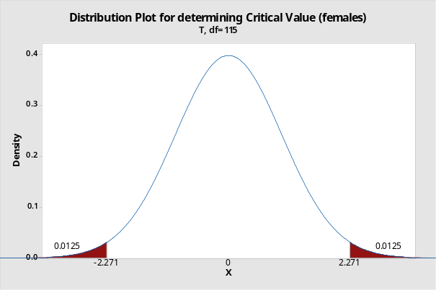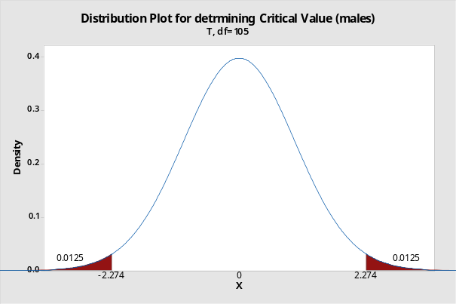

95% Confidence Interval (Females) = Coef of Bodyweight ± Critical Value × SE Coef of Bodyweight
= 0.2732 ± 2.271 × 0.0255
= (0.22, 0.33)
95% Confidence Interval (Males) = Coef of Bodyweight ± Critical Value × SE Coef of Bodyweight
= 0.6796 ± 2.274 × 0.0417
= (0.58, 0.77)
The confidence intervals for both females and males does not contain 0, confirming the decision to reject the null hypothesis that the slope was 0.

Conclusion:
There is a negative linear reaction between the body weight of weightlifters and the maximum weight they can lift for both females and males.

